


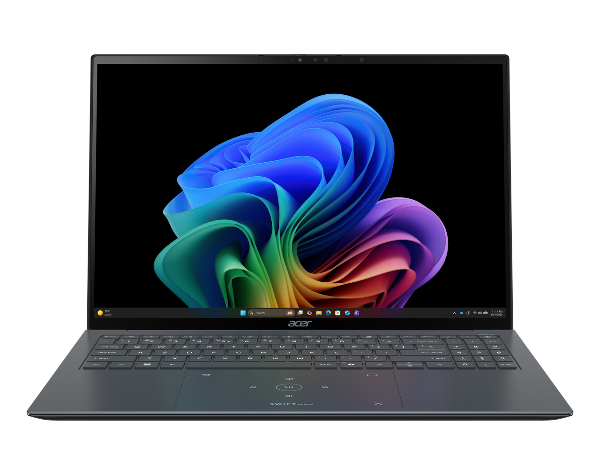

Swift Edge 16 AI

SPECIFICATIONS Swift Edge 16 AI SFE16-I51 | SFE16-I5T

Acer NITRO V 16S ANV16S-71

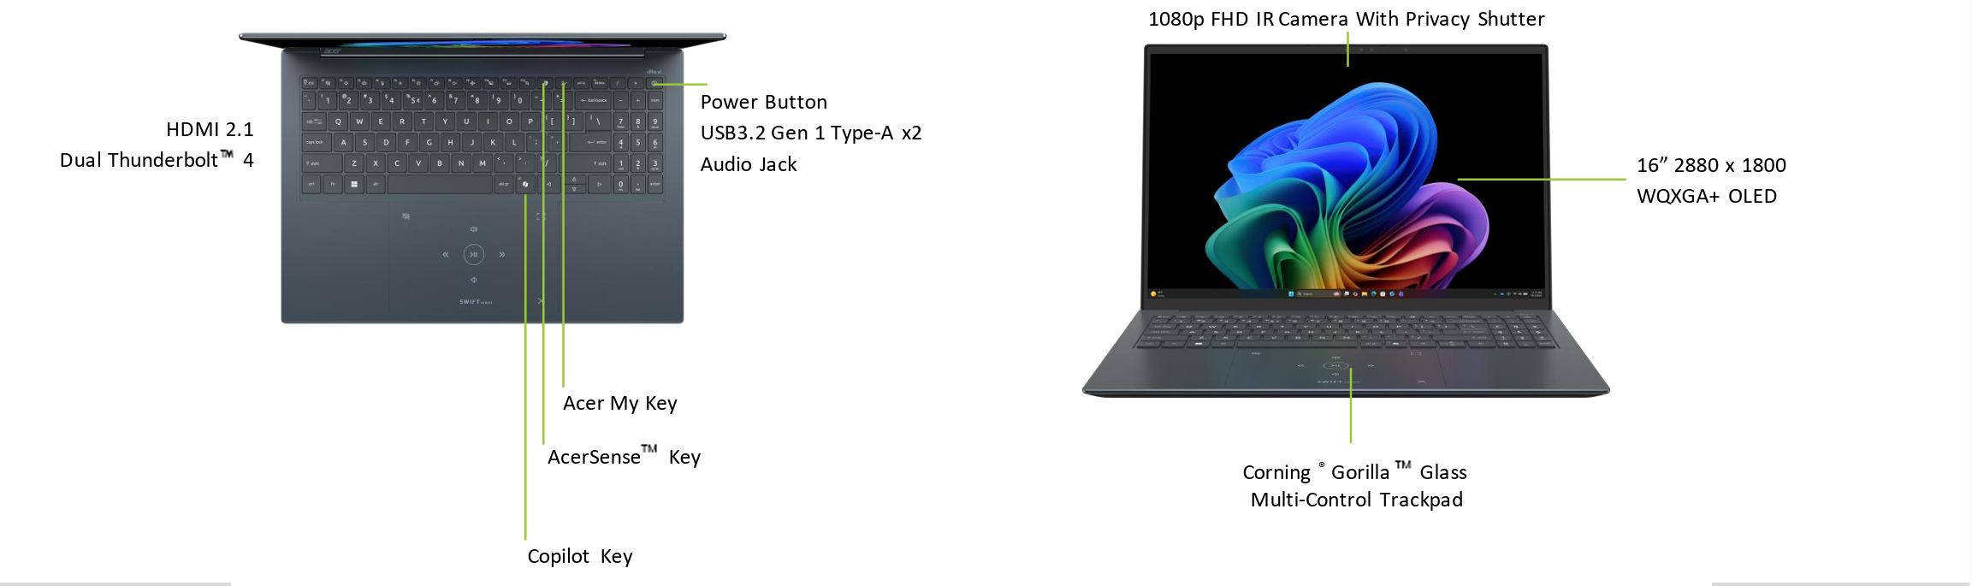
Operating System |  | Windows 11 Home
CPU and Chipset |  | Intel® Core™ Ultra 9 processor 386H
Memory |  | Dual-channel LPDDR5X SDRAM support  16/24/32 GB of onboard LPDDR5X system memory | Memory Frequency : Up to 7467 MT/s
Display |  | Swift SFE16-I51  16.0" display with OLED (Organic Light-Emitting Diode) technology | WQXGA+ 2880 x 1800 | 400 nits brightness, typical | Acer CineCrystal™ | 120 Hz refresh rate | VESA DisplayHDR™ True Black 500 certified  16:10 aspect ratio  100% DCI-P3 color gamut, typical  Peak brightness up to 500 nits in HDR  Wide viewing angle up to 170 degrees  Mercury free, environment friendly |  | Swift SFE16-I51  16.0" display with OLED (Organic Light-Emitting Diode) technology | WUXGA 1920 x 1200 | 300 nits brightness, typical | Acer CineCrystal™  16:10 aspect ratio  100% DCI-P3 color gamut, typical  Wide viewing angle up to 170 degrees  Mercury free, environment friendly |  |  |  | Swift SFE16-I51T  16.0" display with OLED (Organic Light-Emitting Diode) technology | WQXGA+ 2880 x 1800 | 340 nits brightness | Acer CineCrystal™  Integrated multi-touch  16:10 aspect ratio  100% DCI-P3 color gamut  Wide viewing angle up to 170 degrees  Mercury free, environment friendly
Graphics |  | Intel® Graphics eligible  Hardware-accelerated video decode | AVC | HEVC | VP9 | AV1 | VVC  Hardware-accelerated video encode | AVC | HEVC | AV1  Microsoft DirectX® 12  OpenGL® 4.6  OpenCL™ 3.0
Audio |  | DTS® X:Ultra Audio, featuring optimized Bass, Loudness, Speaker Protection with up to 6 custom content modes via embedded smart amplifier  Immersive audio rendering over headphones and internal speakers  Acer Ultra Boost Stereo Speaker Module & PCR 50% material chamber design  High SNR DAC with 2.1 Vrms out capability and can driver high impedance headphone (up to 600 ohm)  Acer Purified.Voice technology with AI noise reduction in 3 mics array built-in microphones to support Advanced Privacy Mode.: Features include far-field pickup, dynamic noise reduction through neural network, adaptive beam forming, and pre-defined personal and conference call modes. |  |  |  |  | Compatible with Cortana with Voice  Acer TrueHarmony Technology for lower distortion, wider frequency range, headphone-like audio and powerful sound  Soundwire Codec with MSFT SDCA 1.0 driver supported  Hi-Res Audio Certification by JAS ( Headphone Output setting supported up to 24bit /192KHz)
Storage |  | Solid State Drive: 512 GB / 1 TB PCIe Gen4, 16 Gb/s, NVMe
Webcam |  | Video Conferencing  UFC with narrow USB FHD camera and IR camera | Blue glass lens | 1920 x 1080 resolution | 1080p video with temporal noise reduction | Staggered high dynamic range (SHDR) | Dual microphones 33 mm + 33 mm | 88 x 3.2 x 2.6 mm | Windows compatible only
Wireless and Networking |  | WLAN:  Killer™ Wi-Fi 7 Wireless LAN  802.11 a/b/g/n/ac/ax/be  Band: 2.4 GHz, 5 GHz, and 6 GHz  2x2 MU-MIMO technology  Multi-Link Operation | WPAN:  Supports Bluetooth® 5.4 or above
Security |  | MSFT Pluton Security Processor as Firmware TPM solution | Camera shutter
Dimensions and Weight |  | Dimensions  357.15 (W) x 244.64 (D) x 7.6/14.6 (H) mm (14.06 x 9.63 x 0.3/0.57 inches) with Metal A Cover |  |  | Weight  1.25 kg with 3-cell battery pack, WQXGA display (SFE16-I5)  1.31 kg with 3-cell battery pack, WQXGA display SFE16-I5T
Power Adapter and Battery |  | Power Adapter  3-pin 100 W PD PCR 50%, TCO 9.0 AC adapter  5 V / 3 A or 9 V / 3 A or 12 V / 3 A or 15 V / 3 A or 20 V / 3.25 A as output power  108.0 (W) x 56.0 (D) x 26.5 (H) mm (4.25 x 2.20 x 1.04 inches)  296 g ± 5% with 150 cm DC cable  Black color with Acer logo  Brick type AC pins | Battery  65 Wh 5614 mAh 11.58 V 3-cell Li-ion battery pack  For models with WQXGA Plus Panel + SSD  Battery life:  Up to 12.5 hours (based on MobileMark® 2030 test results)  Up to 20 hours (based on video playback test results)  Up to 13.5 hours (based on web browsing test results)
Input and Control |  | Keyboard  99 / 100 / 103 keys | Acer backlit keyboard layout | Numeric keypad | International language support  Slim design | 1.3 mm key travel  Dedicated AcerSense key  Programmable key | MyKey  Enlarged keycaps  Adjustable backlight brightness  Quiet design for noise reduction  Caps Lock indicator  Microphone mute indicator  Function Lock key  Numeric keypad |  | Touchpad  Multi-gesture touchpad | Two-finger scroll | Pinch gesture | Gestures to open Cortana | Action Center | Multitasking | Application command gestures  Microsoft Precision Touchpad certification  Moisture resistant  Corning® Gorilla® Glass |  |  |  | Control Keys  Programmable key | My Key  Microsoft Copilot key  AcerSense key
Windows Desktop Apps |  | In-House Applications  Acer AI Image Generator | Acer LiveArt | Acer ORD Service | Acer QuickPanel | Acer VisionArt |  | Search  AcerSense |  | Tools  Acer My Key Application
Warranty |  | One-year International Travelers Warranty (ITW)
Disclaimers
• | Specifications vary depending on model.
• | Shared system memory may be allocated to support graphics, depending on system memory size and other factors. Actual system memory available to the operating system will be reduced by any memory used by the graphics solution and resources required by the operating environment.
• | Memory speed may vary, depending on the CPU, chipset or memory fitted.
• | All brands and product names mentioned herein include trademarks of their respective companies and are used solely to describe or identify the products.
• | Not all features indicated are supported on all SKUs
• | 1 GB is 1 billion bytes. Actual formatted capacity is less and may vary depending on preloaded materials and operating environment. Acer Recovery Management uses a portion of the stated hard disk capacity as dedicated backup space.
• | Minor variations in system dimensions are possible due to the manufacturing process.
• | Weight may vary depending on product configuration, vendor components, manufacturing variability, and selected options.
• | Listed battery life is based on testing using video playback. The test clip loops and continues to run, without interruption or any other inputs, until the battery is drained. Stated battery life is for comparison purpose only. Actual battery life varies by model, configuration, applications, video chip format and features used. A battery's maximum capacity decreases with time and use. Battery life test configuration: Intel® ULTRA 7 (Series 3), Intel® Graphics, WQXGA+ OLED, SSD only, 32GB of LPDDR5X memory. Battery life test condition: LCD brightness 150 nits, connected headphones, WLAN off, Bluetooth off and Better Battery Mode on.
• | Listed battery life is based on testing using Web browsing. The test clip loops the loading of 50 selected websites using Microsoft Edge every 30 seconds, until the battery is drained. Stated battery life is for comparison purpose only. Actual battery life varies by model, configuration, applications, video chip format and features used. A battery's maximum capacity decreases with time and use. Battery life test configuration: Intel® ULTRA 7 (Series 3), Intel® Graphics, WQXGA+ OLED, SSD only, 32GB of LPDDR5X memory. Battery life test condition: 100 nits LCD brightness, 50% speaker volume, WLAN on, Bluetooth on, no WW direct Internet connection.
• | Actual battery life may vary considerably by specifications, depending on product model, configuration, applications, power management settings, operating conditions, and features utilized. Performance variation also arises based on components in use, which includes but is not limited to the processor, RAM capacity, storage, display and resolution, etc.
• | Bundled software may vary depending on hardware configuration, OS and regional availability.
Product Sheet is based on Swift SFE16-I51T (Win11) Specifications (v1-0-0) (Preview) and Swift SFE16-I51 (Win11) Specifications (v1-0-0) (Preview)
In a continuing effort to improve the quality of our products, information in this document is subject to change without notice. Images shown are only representations of some of the configurations available for this model. Availability may vary depending on region. As a phenomenon known to thin-film transistors (TFTs), liquid crystal displays (LCDs) commonly exhibit a small number of discoloration dots, as so-called "non-conforming pixels." This phenomenon is a limitation of TFT LCD technology, not a product defect, and as such is not covered by Acer's warranty.
© 2026. All rights reserved.
Microsoft and Windows are registered trademarks of Microsoft Corporation.
3D XPoint, Agilex, Altera, Arc, Arria, Avalon, Axxia, Barefoot Networks, the Barefoot logo, the Footsie logo, Celeron, Cyclone, Docae, DoubleShot, eASIC, easicopy, FlexRAN, Gaudi, Granulate, HyperFlex, Intel, the Intel logo, Intel Adapix, Intel Agilex, Intel Atom, Intel Cofluent, Intel Core, Intel Evo, Intel Geti, Intel Inside, the Intel Inside logo, Intel Optane, Intel RealSense, Intel SpeedStep, Intel Tiber, Intel Unison, Intel vPro, Iris, Killer, Linux, MAX, Movidius, Myriad, Nios, OmniBridge, OpenVINO, the OpenVINO logo, Pentium, Quartus, Simics, SmartByte, SoFiaSilicon, Sound Mark, StarPro, Stay With It, the Engineering Stay With It logo, Stratix, the Stratix logo, the Journey Inside, Thunderbolt, the Thunderbolt logo, Tofino, Ultrabook, VTune, and Xeon are trademarks of Intel Corporation or its subsidiaries.
About Acer
Founded in 1976, Acer is one of the world's top ICT companies with a presence in more than 160 countries. As Acer evolves with the industry and changing lifestyles, it is focused on enabling a world where hardware, software and services will fuse with one another, creating ecosystems and opening up new possibilities for consumers and businesses alike. Acer's 7,500 employees are dedicated to the research, design, marketing, sale, and support of products and solutions that break barriers between people and technology. Please visit www.acer.com for more information.

